VM Build via PSSIT portal

========================================

* 1. Prerequisites: sample below

|  |  |
| --- | --- |
| **Prerequisites** | |
| **Client Code** | 152 (CATS) |
| **Server name** | lr152infxxxxx |
| **Location** | monosite Diderot |
| **Backup** | Yes |
| **Monitoring** | Monitoring 24/7 |
| **VLAN number** | QABE (qualification) |
| **CMDB Description** | VM4 for STT SecureTransport OPEN OPR |
| **IP** | 1 |
| **CPU** | 8 |
| **RAM** | 16 |
| **Application Code** | APP00032254 |
| **Patch Day Timeslot** | First Wednesday |
| **Patch Hour Timeslot** | 19h00 |

* 1. PSSIT portal login page: <https://pssit.saas.cagip.group.gca>

Login credentials: partenaires.local

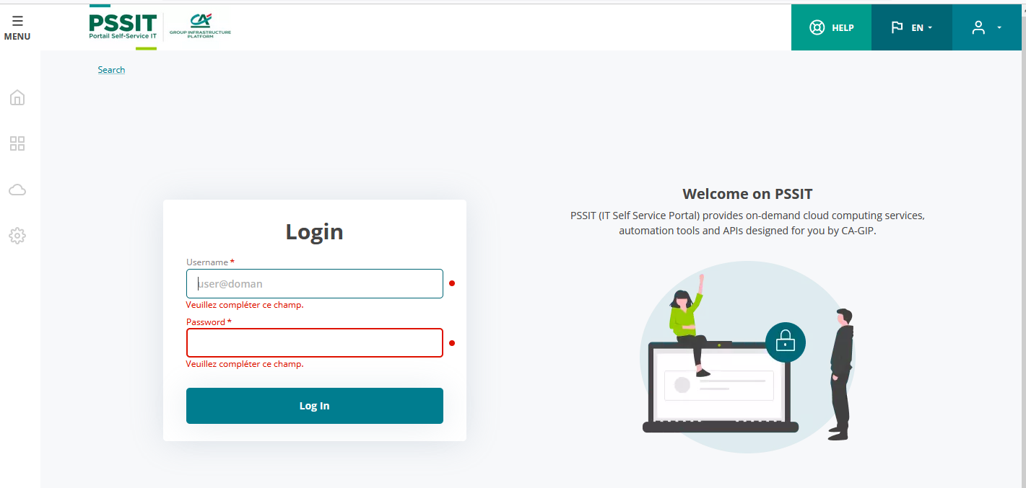

* 1. Click cloud resource and select service catalog:

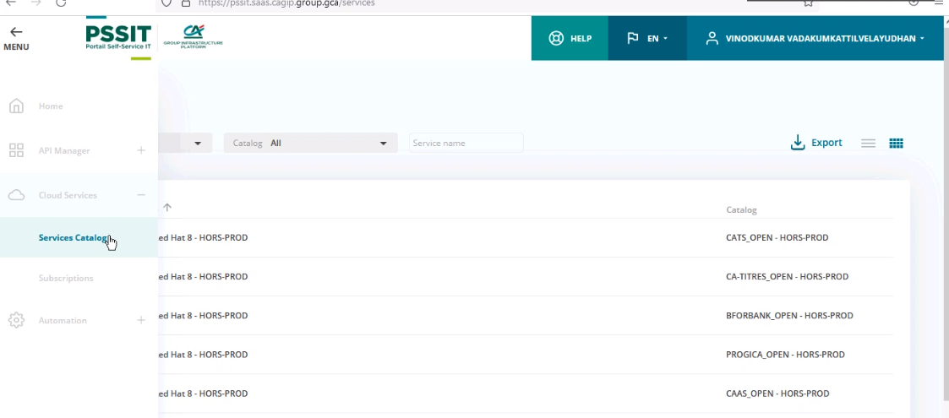

* 1. Select company name as **CATS** and need to choose production or non-production

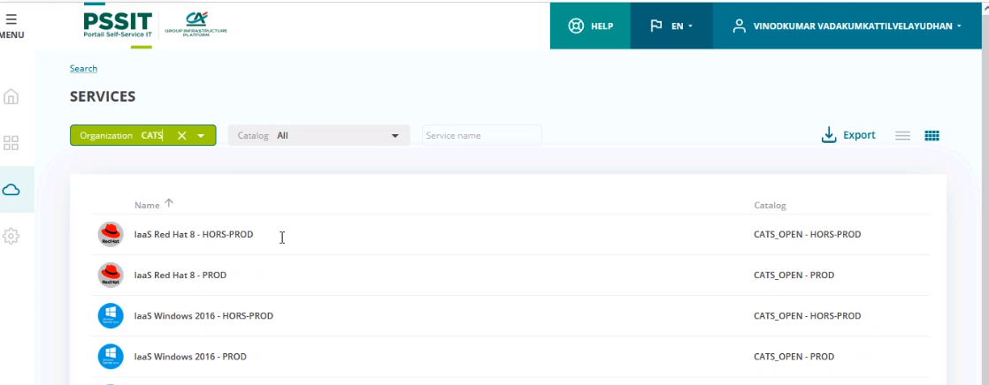

* 1. Once select environment(prod or non-prod) click order icon

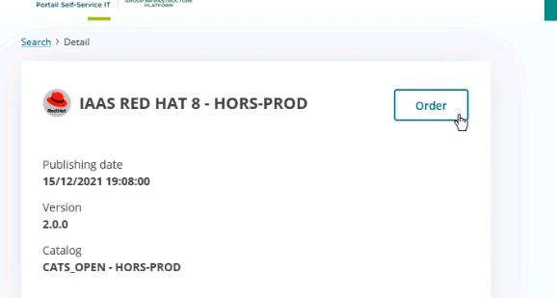

* 1. Select Customer as per request   
     select **Caisse Régionale Communautaire** for client code **800**  
     select **CATS SI** for client code **152**

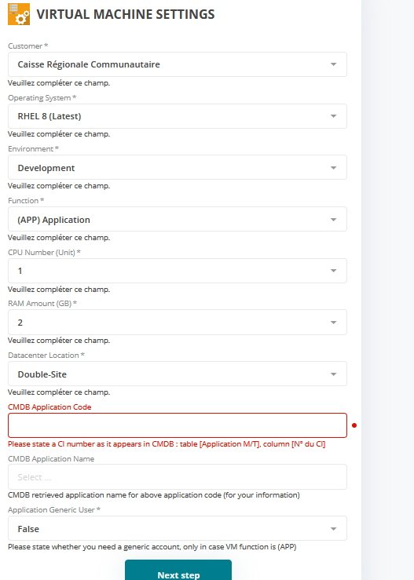

* 1. We need to provide CMDB application code it will fetch application name.

If the application code didn’t received with RITM need to check with requester.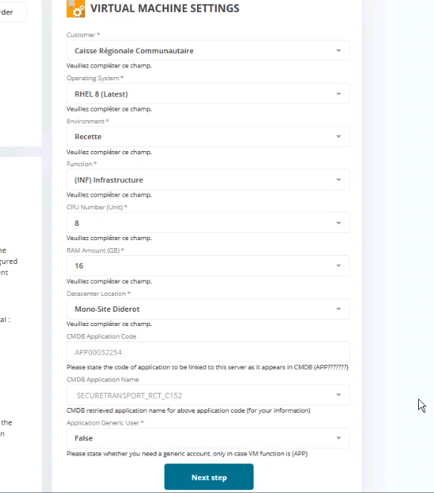

* 1. Do not change applivg size by default its 20GB, if required will add new disk after VM build

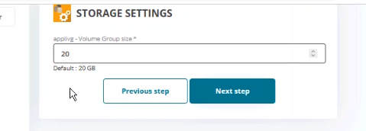

1.11 Select the Network Zone

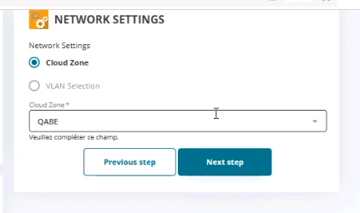

1.12 Choose backup service, monitoring and Patch Timeslot as per requestor confirmation.

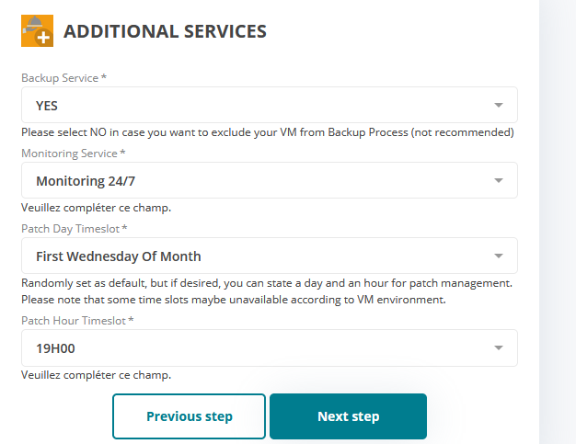

1.14 Select environment

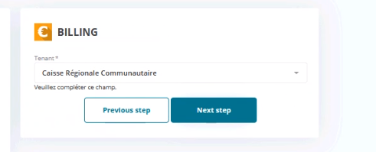

1.15 Provide CMDB description on Subscription name field.

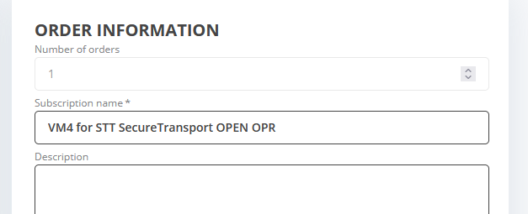

1.16 Validate inputs and click on order now for starting VM build, if required use modify button to make changes.

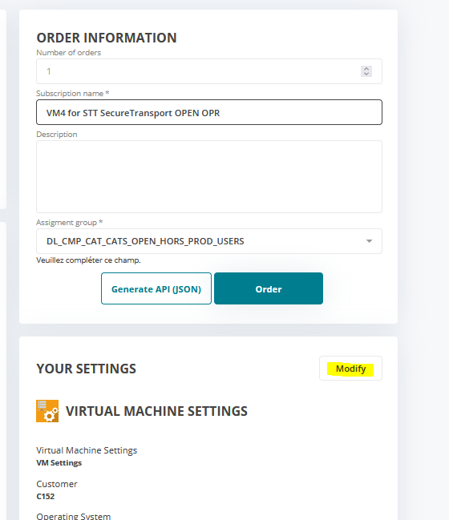

1.17 Save VM creation ID for checking with cloud team in case of any failure.

1.18 Go to cloud services🡪 subscriptions🡪 select newly build VM🡪 Click BUILD LOGS for checking build progress.

